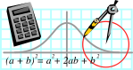  Rossmoyne SHS  Mathematics  Department | MATHEMATICS  3AB MAT | Semester 1 2011  EXAMINATION

NAME:
TEACHER: Belonogoff Benko Fletcher Goh Longley Pui

(Circle one name) Rigelsford Robinson Tanday Tay White Whyte

Section Two:
Calculator-assumed

Time allowed for this section
Reading time before commencing work: 10 minutes
Working time for this section: 100 minutes

Materials required/recommended for this section

To be provided by the supervisor
This Question/Answer Booklet
Formula Sheet (retained from Section One)

To be provided by the candidate
Standard items: pens, pencils, pencil sharpener, eraser, correction fluid, ruler, highlighters

Special items: drawing instruments, templates, notes on two unfolded sheets of A4 paper, and up to three calculators satisfying the conditions set by the Curriculum Council for this examination

Important note to candidates
No other items may be taken into the examination room. It is your responsibility to ensure that you do not have any unauthorised notes or other items of a non-personal nature in the examination room. If you have any unauthorised material with you, hand it to the supervisor before reading any further.
Structure of this paper

Section | Number of questions available | Number of questions to be answered | Suggested working time  (minutes) | Marks  available
Section One:  Calculator-free |  |  | 50 | 40
Section Two:  Calculator-assumed | 13 | 13 | 100 | 80
 |  |  |  | 120

Instructions to candidates

- The rules for the conduct of Western Australian external examinations are detailed in the Year 12 Information Handbook 2010. Sitting this examination implies that you agree to abide by these rules.

2. Answer the questions according to the following instructions.

Section Two: Write answers in this Question/Answer Booklet. All questions should be answered.
Show all your working clearly. Your working should be in sufficient detail to allow your answers to be checked readily and for marks to be awarded for reasoning. Incorrect answers given without supporting reasoning cannot be allocated any marks. For any question or part question worth more than two marks, valid working or justification is required to receive full marks. If you repeat an answer to any question, ensure that you cancel the answer you do not wish to have marked.
It is recommended that you do not use pencil except in diagrams.

3. You must be careful to confine your responses to the specific questions asked and to follow any instructions that are specific to a particular question.

- Spare pages are included at the end of this booklet. They can be used for planning your responses and/or as additional space if required to continue an answer.
  - Planning: If you use the spare pages for planning, indicate this clearly at the top of the page.
  - Continuing an answer: If you need to use the space to continue an answer, indicate in the original answer space where the answer is continued, i.e. give the page number. Fill in the number of the question(s) that you are continuing to answer at the top of the page.

QUESTION | MARKS AVAILABLE | STUDENT MARK
1 | 6
2 | 3
3 | 4
4 | 8
5 | 8
6 | 6
7 | 12
8 | 8
9 | 5
10 | 6
11 | 3
12 | 4
13 | 7
TOTAL | 80

SECTION B
APPROVED CALCULATORS PERMITTED FOR THIS SECTION
TIME: 100 minutes
MARKS ALLOCATED 80 marks
Question 1. (1,1,2,1,1 marks)

Mr and Mrs Smith have borrowed $250 000 to purchase a unit for their son. They would like to repay their loan at $2 500 per month. Below is a monthly summary for the first 18 months of the repayment of the loan.

Month | Balance at start of month | Interest | Repayment | Balance at end of month
1 | 250 000.00 | 1 250.00 | 2 500.00 | 248 750.00
2 | 248 750.00 | 1 243.75 | 2 500.00 | 247 493.75
3 | 247 493.75 | 1 237.47 | 2 500.00 | 246 231.22
4 | 246 231.22 | 1 231.16 | 2 500.00 | 244 962.37
5 | 244 962.37 | 1 224.81 | 2 500.00 | 243 687.19
6 | 243 687.19 | 1 218.44 | 2 500.00 | 242 405.62
7 | 242 405.62 | 1 212.03 | 2 500.00 | 241 117.65
8 | 241 117.65 | 1 205.59 | 2 500.00 | 239 823.24
9 | 239 823.24 | 1 199.12 | 2 500.00 | 238 522.36
10 | 238 522.36 | 1 192.61 | 2 500.00 | 237 214.97
11 | 237 214.97 | 1 186.07 | 2 500.00 | 235 901.04
12 | 235 901.04 | 1 179.51 | 2 500.00 | 234 580.55
13 | 234 580.55 | 1 172.90 | 2 500.00 | 233 253.45
14 | 233 253.45 | 1 166.27 | 2 500.00 | 231 919.72
15 | 231 919.72 | 1 159.60 | 2 500.00 | 230 579.32
16 | 230 579.32 | 1 152.90 | 2 500.00 | 229 232.21
17 |  |  | 2 500.00
18 |  |  | 2 500.00

(i) What is the monthly interest rate?

(ii) What is the yearly interest rate?

(iii) Complete the last 2 rows of the table (round your answers to the nearest cent).

(iv) Write a recursive formula to determine the amount owing at the start of each month.

(v) How long (in months) will it take them to completely pay off the loan?

Question 2. (1,1,1 marks)

Each year the value of a car depreciates by 15% of its value at the beginning of that year. If the car is initially worth $20 000, determine:

(a) an expression for the value, V , of the car after n years.

(b) the value of the car after 10 years.

(c) in how many years’ time will the value of the car fall below $1000? (to the nearest year.)

Question 3 (2,1,1 marks)

The resistance, R ohms, to the flow of electricity in a wire varies inversely as the area of cross-section of the wire, A.

(a) Given that when A = 0.15 cm² , R = 0.24 ohms.
Write an equation connecting the two variables R and A.

(b) Determine

(i) R when A = 0.07 cm²

(ii) A when R = 0.45 ohms.

Question 4 (4,4 marks)

(i) (ii)
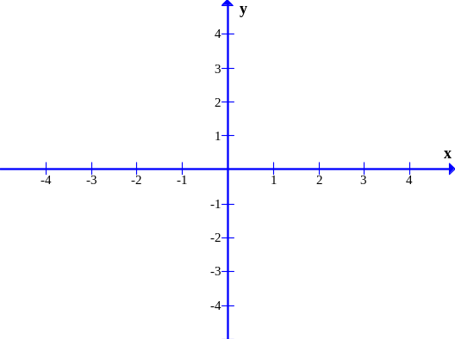
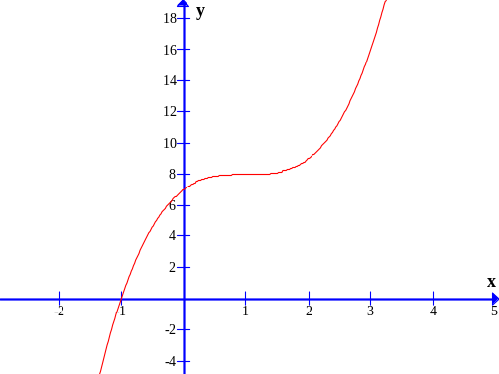

(iii) (iv)
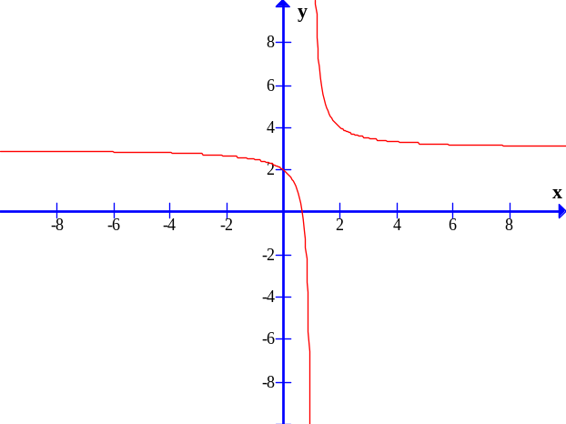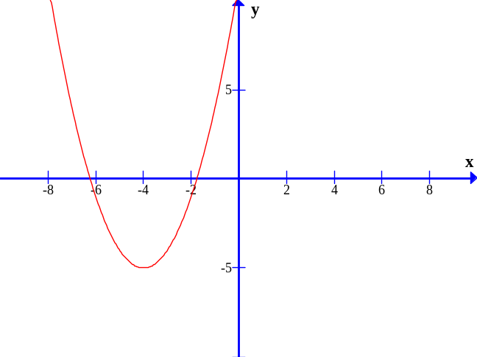

(a) Match the graphs of the above curves with the following equations:

y = 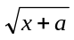 y = 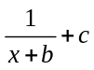 y = (x + d)³ + e y = f ^{x} + g y = (x + h)² + j

Write the equation in the table provided below.

Graph (i) | Graph (ii) | Graph (iii) | Graph (iv)

(b) Hence, find the unknowns (i.e. a, b, c, d, e, f, g, h, j) related to each equation respectively and write your answer in the table provided below. (Write n/a if not applicable.)

a | b | c | d | e | f | g | h | j

Question 5 (1,1,1,1,2,2 marks)

(a)

The graphs below represent four different relationships between the variables x and y.

x
y
x
y
x
y
x
y
Graph A
Graph B
Graph C
Graph D

(i) Which graph(s) represent a direct proportion between x and y?

(ii) Which graph(s) represent an inverse proportion between x and y?

(iii) Suggest an equation that would represent:

(I) Graph B

(II) Graph D
(b) For the cubic graph reproduced below, give a qualitative description of the function in the spaces below. (Note: calculations are not required.) However, you may wish to consider the following in your description of the function (i.e. intercepts, lines of symmetry, turning points, concavity, points of inflection, etc.)
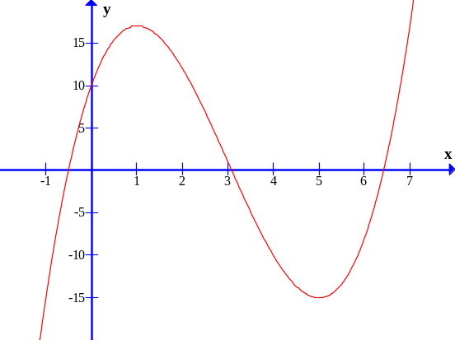

(c) The hyperbolic curve below has both horizontal and vertical asymptotes. State the value/s of x and y for which the asymptotes occur.
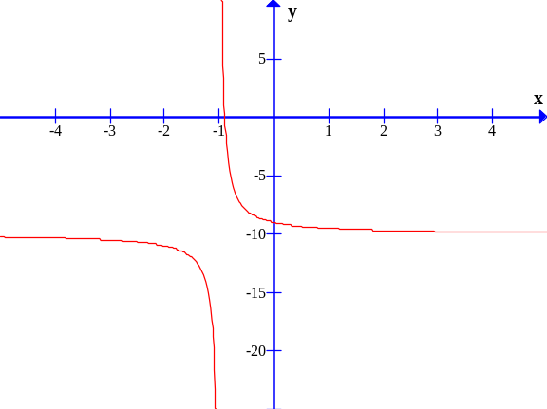

Question 6 (6 marks)

A function  is constructed from parts of a cubic and parabolic functions as shown in the diagram below.
(a) Show on the axes below the function defined as 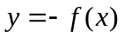
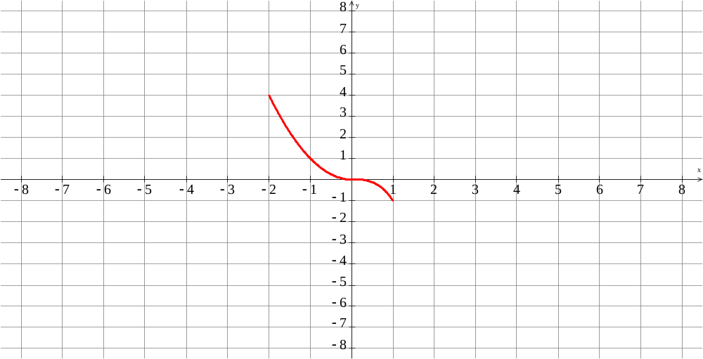
(b) Show on the axes below the function defined as 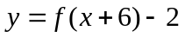
(c) Show on the axes below the function defined as 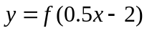
Question 7 (2,2,2,2,2,2 marks)

(a) A sequence is defined by 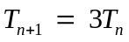 with 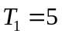. Determine the sixth term, 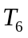.

(b) A sequence has the recursive formula 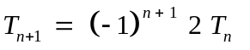 with 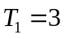.
Determine the fifth term.

(c) A rocket is fired upwards and its initial speed is 147 metres per second. After 1 second its speed is 137.2 ms⁻¹, after the next second it is 127.4 ms⁻¹, and each subsequent second its speed is reduced by 9.8 ms⁻¹.

(i) When does its speed drop to zero?

(ii) What is the greatest height reached?

(d) Simplify, and hence evaluate:

(i) 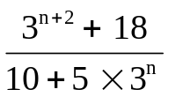

(ii) 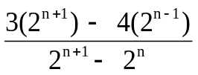

Question 8 (2,2,2,marks)

(a) Determine the possible value/s of x (in degrees) given that the triangle has an area of 22.3 cm².
5 cm
12 cm
xº
( Diagram not drawn to scale )

(b) A coastal observation position is known to be 3 km from a lighthouse. The coastguard in the observation position is in radio and visual contact with a ship in distress at sea. If the coastguard looks towards the lighthouse and then towards the ship these two directions make an angle of 42º with each other. If the captain on the ship looks towards the observation position and then towards the lighthouse these two directions make an angle of 110º with each other. (The ship, the lighthouse and the observation position may all be assumed to be at sea level).

(i) Draw a clearly labelled diagram below to show the situation.

(ii) How far is the ship from the lighthouse?

Question 9 (5 marks)

Amy started walking to school from home at 8.15 a.m. The graph below shows the distance from home against her walking time. This morning the walk to school was unusual.

Walking to school
500
1000
1500
3
4
6
12
9
2
1
5
7
8
10
11
13
14
Time (minutes)
Distance from home (metres)

(a) When did Amy realize that she had forgotten her homework?

(b) How far was she from home?

(c) What did she do and how long did it take?

(d) What do you think happened in the two-minute period between 4 minutes and 6 minutes?

(e) How fast was she “walking” in the period a few minutes before arriving in school?
(Give your answer in metres per minute.)

Question 10 (3,1,1,2 marks)

A scientist collects 40 butterflies of a particular species and measures the lengths of the wing span of each one. The lengths, to the nearest millimetre, are shown in the dot frequency diagram below.

Wing Span (mm)
Frequency
5
70
80
90
100
110
120
130
140

(a) Calculate the mean and standard deviation for this set of lengths.

(b) What percentage of the lengths lie within one standard deviation of the mean (i.e. mean ± 1 s.d.)?

(c) Determine the interquartile range for this set of data?

(d) Is the length of one particular butterfly with a wing span of 129 mm considered an outlier in this data set? Explain.

Question 11 (1,2 marks)

In January last year, 150 black bream were tagged and released into the Swan River. In June the same year, during a fishing competition, 40 black bream were caught and 8 of them had tags. The tagged fish were released back into the river.

(a) Estimate the population of black bream in the Swan River in June last year.

Another fishing competition in January this year resulted in 60 black bream being caught. Fifteen of these had tags.

(b) Does the population of black bream in the Swan River appear to be increasing or decreasing? Justify your answer.

Question 12 (4 marks)

The histogram below shows the distribution of scores achieved by students in a Mathematics exam.

10
20
30
40
50
60
70
80
90
1000
30
20
10
12
18
29
19
13
9
5
3
1
Score
Frequency

Describe the distribution of marks in this exam.

Question 13 (1,1,1,1,1,3 marks)

(a) Determine
(i) P(X < 55) where X ~ N(45, 10²)

(ii) P(30 < X < 60) where X ~ N(40, 81)

(b) The annual rainfall in equatorial Batam island, is normally distributed with a mean of 1300 mm and a standard deviation of 250 mm. According to this model, and assuming that the situation does not change, in every one hundred years how many years would you expect the rainfall to be:

(i) less than 850 mm

(ii) more than 1600 mm

(iii) between 850 mm and 1600 mm

(c) In the town of Margaret River, the annual rainfall is normally distributed with a standard deviation of 380 mm. If there is only a 10% chance that the annual rainfall is greater than 2050mm, determine the mean annual rainfall.

End of paper.

